1)My project using Infragistics Winform control version 18.2 ,using visual studio version 2015

CLR 4.0

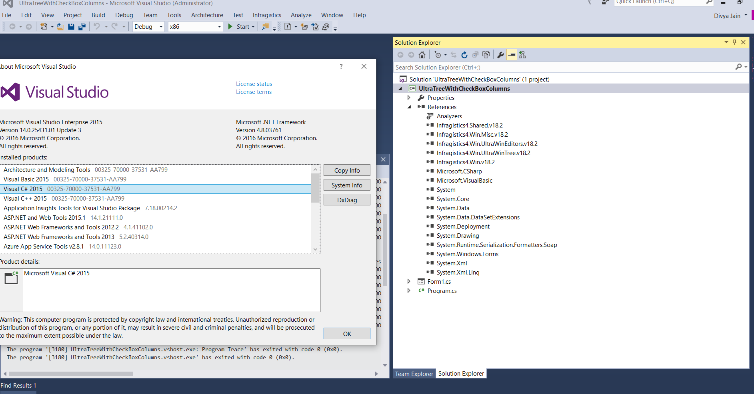

2)Right click the solution and select the upgrade option

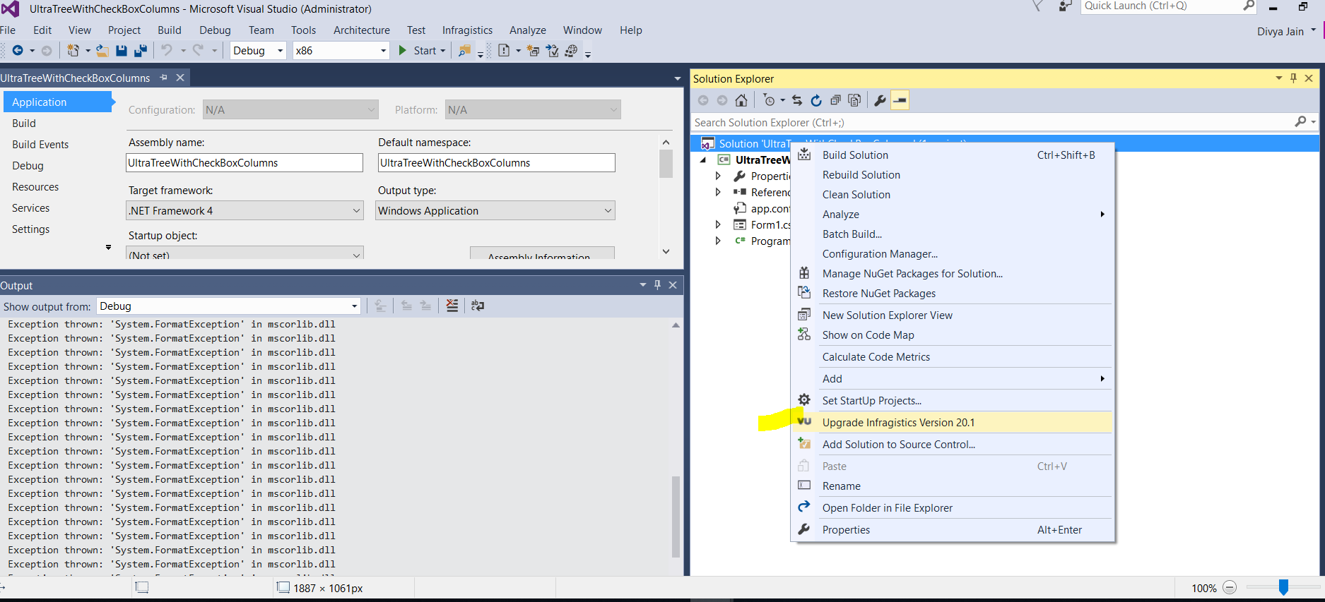

3)Got this upgrade dialog

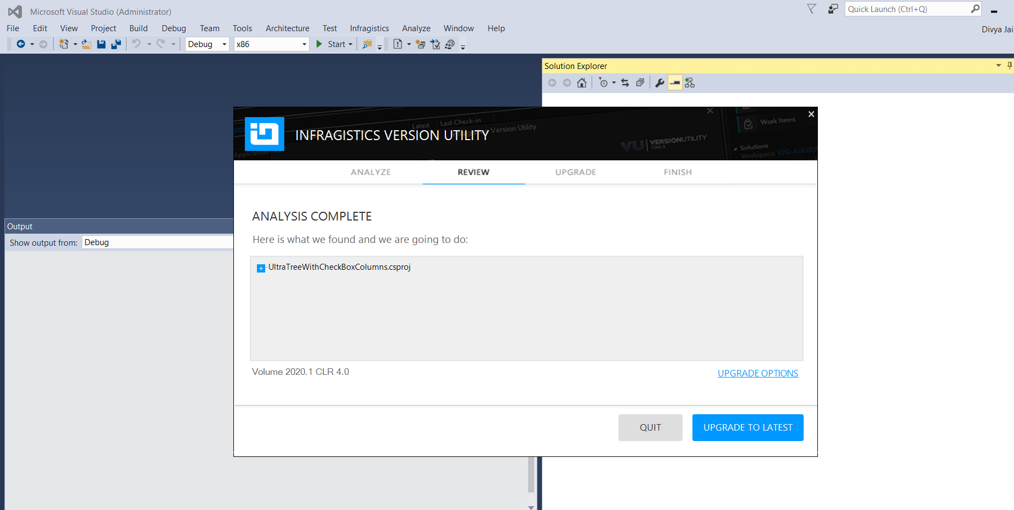

4)Project upgraded successfully

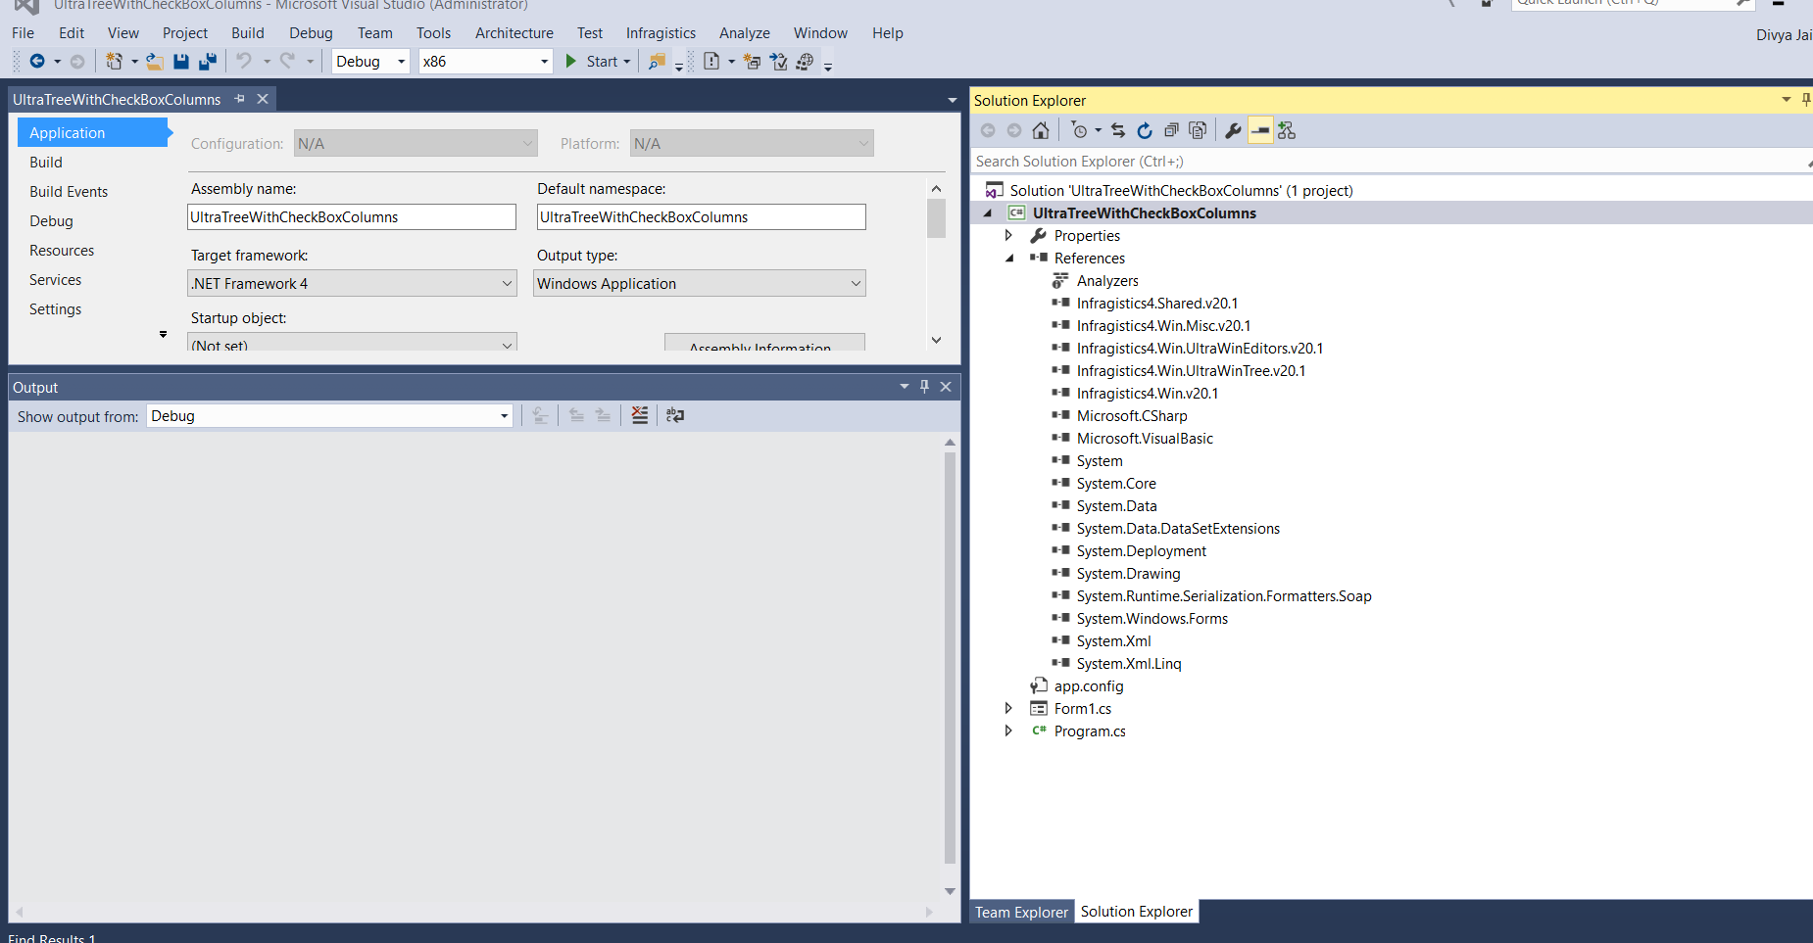

5)Run the sample.

Note: You can do this exercise by simply creating a test empty sample and add all the 18.2 dlls into the reference section, then follow these instructions …if this goes successful then the issue must be something in your project causing this issue.

Or may be the version utility you are using has some issue , since I am not families with the UI.

If you install the version utility while running the installer of 20.1 then you would have that ‘upgrade infragistics version 20.1’ on project solution right click.

Once your project upgraded successfully ,as per our support environment page ,use visual studio 2017/2019 ,CLR 4.5 or higher .

<https://www.infragistics.com/support/supported-environments>

-Divya Jain